Course Project – Programming Fundamentals [Spring 2023]

Submission Guideline

* Submission deadline is 12th May, Friday.

You have to make a simulator of cricket match. Make two teams of 7 players each. Each player will have his name, runs scored, balls faced, balls bowled, runs given, wickets taken. **[use 1D/2D/3D arrays]**.

Your match simulation will be performed using excessive use of random function. The execution of the simulation will be in the following order

* Match will be simulated for N number of overs. Value of N will be read from the configuration.txt file. **[use filing]**
* Toss will be done and any team can win the toss and bat first. **[random function]**
* Player 1 and Player 2 of the batting team will appear on the score card. Player 1 will face the first ball. Later on, the batsman facing the ball will be decided as follows:
  + Score 1,3,5 will mean other end batsman will face next ball.
  + Over completed means other end batsman will face next ball.
* Bowler 1 will be the last player of Team B. Bowler 2 will be the second last player of team B and so on. Last five players of Team B will be bowlers. Each bowler can bowl a maximum of total overs/5 overs (e.g. for a 20 over match, maximum overs bowled by a bowler would be 4).
* Ball will be bowled by pressing ENTER key. Each ball bowled will get a hit which will get some score randomly (-1 – 6). If -1 comes, batsman is declared OUT. **[Scoreboard changes will be done by drawing another scoreboard with new values. You should have your own function to draw() scoreboard again with new values which should be passed to the function.]**
* All batsmen don’t have same probability of getting out, that is, a bowler (player number 6 to 11) will have 50% chance of getting out on each ball and 50% of getting any score from 0-6. Similarly, a batsman (player number 1 to 5) will have 10% chance of getting out and 90% chance of getting scores 0-6 on each ball.

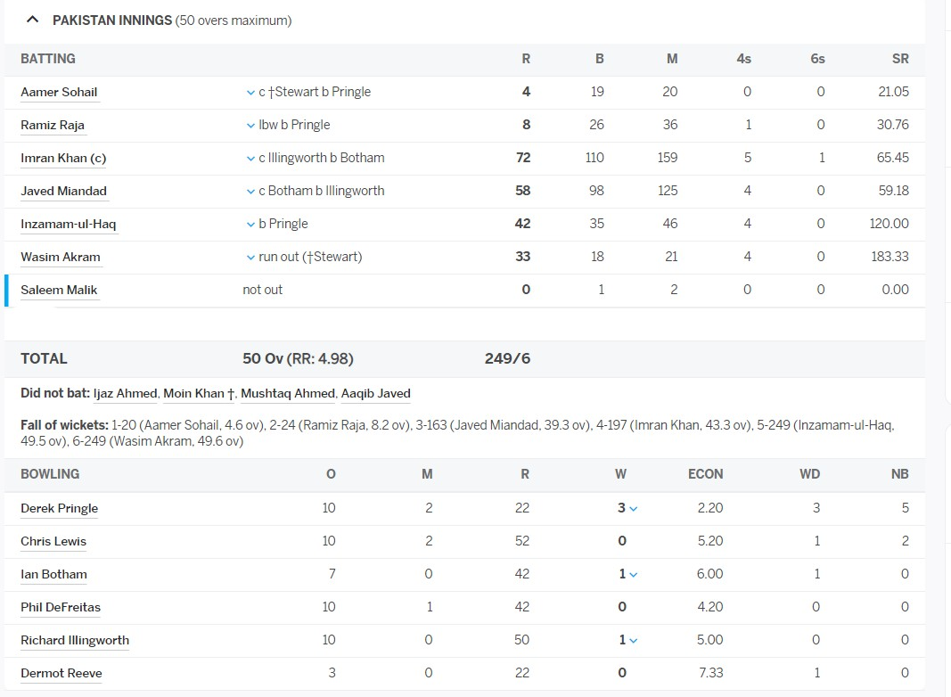

* There should be a function to find total score to be displayed on the scorecard; Scorecard should also be displayed by a function. Total score is actually sum of scores of all players who batted. Similarly, total dismissed is sum of all players who got out.
* If a batsman is DISMISSED/OUT, his score card will be displayed until ENTER is pressed again. After that, main score card is displayed again. **[You can use ENTER as input by using cin.get() or getchar() function. ]**



* The innings of the team playing first will end if all overs are bowled or all players are dismissed. In any case, full scorecard should be displayed showing full innings summary.
* Seconds innings will be executed same as before except that the target, remaining score and remaining overs are also included in the score card. You don’t need to display first innings scoreboard when second innings is being played.

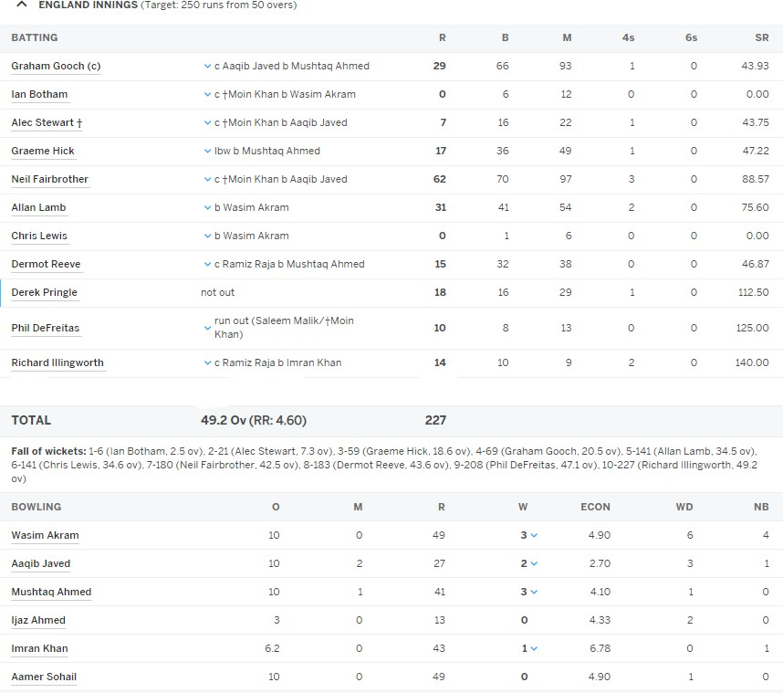

* When match is finished, user gets an option to show a short summary of the match and save match data on file. **[Use files to write and read match data, switch statement to display a menu]**

# Result

# (This data has to be stored in a file if user chooses save data on file option.)

* Bowler taking highest wickets will be declared bowler of the match.
* Batsman scoring highest runs will be declared batsman of the match.
* Team winning will be shown as winner.

# Critical Restrictions/Instructions

* If a programming construct other than those taught in the course is used, your project will get ZERO.
* If plagiarism is found, F may be awarded for the entire course.
* Evaluation of this project will be held, so make sure to do it yourself.

# Rubric

|  |  |
| --- | --- |
| **Task** | **Marks** |
| Using arrays (1D, 2D, ..) to make teams. | 10 |
| Calculating correct probability of scoring or getting out for the batsmen and bowlers. | 10 |
| Function to draw live scoreboard repeatedly (draw with new values) | 10 |
| Sub-function to draw live score card -> calculate total score | 10 |
| Sub-function to draw live score card -> fall of wickets | 10 |
| Sub-function to draw live score card -> overs bowled | 10 |
| Sub-function to draw live score card -> batting board | 10 |
| Sub-function to draw live score card -> bowling board. | 10 |
| Final result (bowler and batsman of the match, winning team, match summary) | 10 |
| Game configuration file to define number of overs. | 10 |
| Write match data in a file | 10 |
| Error free program (even if it is not fulfilling all requirements – 50% functions must be implemented) | 10 |
| Properly formatted scorecard, similar to the images given above. | 10 |
| Properly formatted/indented and commented program code | 10 |
| **Total marks** | **140** |